Download raspbian:  
<https://www.raspberrypi.org/downloads/raspbian/>

Download win32diskimager:  
<http://www.chip.de/downloads/Win32-Disk-Imager_46121030.html>

Flash the raspbian image with win32diskimager:

1. Unzip the raspbian image
2. Open Win32DiskImager
3. Select the image file
4. Select your SD-Card
5. “Write” to the SD-Card

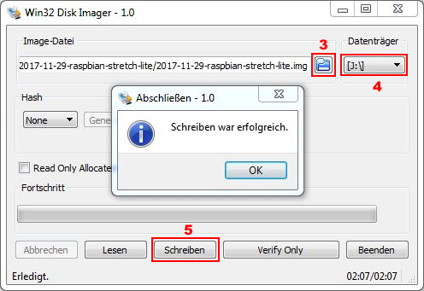

Open your SD-Card with the windows explorer and create a file called “ssh”  
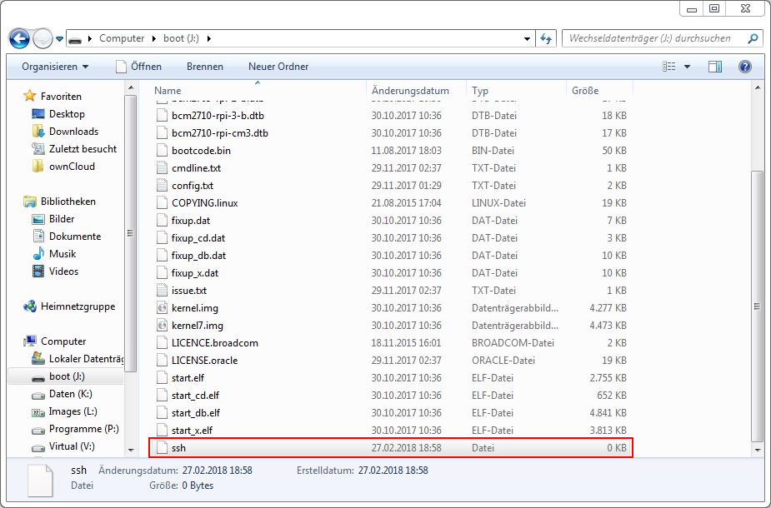

Now put the SD-Card into your raspberry, connect the Ethernet cable with your local network and the power supply.

Find out the ip address of your raspberry:

* Using the client list of your router
* Or an app on your smartphone like Fing:  
  <https://play.google.com/store/apps/details?id=com.overlook.android.fing&hl=de>

Connect to your raspberry-pi:

1. Get a SSH-Client like “Bitwise-SSH”
2. Type in the IP-Address of your pi
3. Type in the username “pi”
4. Type in the password “raspberry”
5. Login to the raspberry

